AUTOMATED TOUR RECOMMENDATION SYSTEM FOR HTUNDLA SAFARIS

ODHIAMBO JUSTIN GABRIEL - 1049072

A PROJECT REPORT PRESENTED TO CATHOLIC UNIVERSITY OF EASTERN AFRICA, FACULTY OF SCIENCE, DEPARTMENT OF COMPUTER SCIENCE, IN PARTIAL FULFILLMENT OF THE AWARD FOR THE DEGREE IN BACHELOR OF SCIENCE IN COMPUTER SCIENCE

DATE: OCTOBER, 2025


CATHOLIC UNIVERSITY OF EASTERN AFRICA

PROJECT REPORT FOR FINAL YEAR STUDY IN COMPUTER SCIENCE
BY
ODHIAMBO JUSTIN GABRIEL (1049072)

AUTOMATED TOUR RECOMMENDATION SYSTEM FOR HTUNDLA SAFARIS

DATE: OCTOBER, 2025

Submitted in partial fulfillment of the requirement for the Degree in Computer Science

Declaration and Approval
Student
I, Odhiambo Justin Gabriel declare this research report is my original work and that it has not been presented in any other university or institution for academic credit.
Signature.......................... Date.......................................

Supervisor’s Approval
This research report has been submitted for examination with my approval as university
supervisor.
Signature.......................... Date.......................................
Name: Dr. Stanley Chege

Head of Department’s Approval
This research report has been submitted for examination with my approval as the head of department.
Signature.......................... Date.......................................
Name: Mr. Kinyua

Acknowledgment
Above all, I want to express my gratitude to God for all of His help, support, and blessings during this project's life cycle. His never-ending love and granting me good health, spiritual nourishment and a sound mind has really been a huge player in my endurance through this course and in times of difficulty. All of this would not have been possible without His grace.
My profound appreciation also goes out to Dr. Stanley Chege, who provided vital and exemplary guidance, inspiration, support, and perceptive criticism during this process. The success of this endeavour has been greatly attributed to your support.
My sincere gratitude goes out to my family and friends for their patience, love, and support. I have the willpower and fortitude to finish my assignment because of your encouragement. I am blessed for I know whatever I pursue I will always have your backing.
I appreciate each and every one of your priceless contributions and faith in me.

Dedication
The entirety of my efforts put into this proposal is dedicated to my close family and best mates. My greatest strength has been their consistent support, encouragement and active participation in my life. Their undying efforts have been a cornerstone to this entire journey.

Abstract
This project proposes the development of an Automated tour recommendation and booking support system designed for Htundla Safaris, a tour operator in Kenya specializing in safari and MICE (Meetings, Incentives, Conferences, and Exhibitions) tourism. Through an intelligent, conversational web interface, the system aims to enhance customer interaction and expedite the process of itinerary planning. Tourists will engage with a chatbot that poses pre-programmed questions to obtain key information such as preferred destinations, activities, travel style, and duration. Based on this input, the system will generate a customized itinerary and activity plan using a hybrid recommendation engine that combines rule-based filtering and content-based AI techniques (specifically TF-IDF and cosine similarity algorithms).
The web-based platform will be developed using HTML, CSS, JavaScript for the front end to ensure a responsive and engaging user interface. The Django framework will serve as the backend for managing business logic and API endpoints, while MySQL will be the main database for storing user, package, and recommendation data. The automated logic will be implemented in Python, integrated with Django through a recommendation module that dynamically processes and ranks package data.
Unlike fully automated systems, the proposed solution introduces a human-in-the-loop model: while the automated system will recommend activities and generate an itinerary, a human tour operator from Htundla Safaris will finalize the cost sheet and confirm bookings. This hybrid model ensures both personalization and accuracy in pricing. From an academic standpoint, the project demonstrates how web technologies and artificial intelligence can be combined to address practical challenges in Kenya’s tourism industry, particularly the lack of intelligent, personalized, and partially automated digital assistance for tourists thus improving both customer experience and operational efficiency for local tour operators.

Table of Contents
Declaration and Approval ii
Acknowledgment iii
Dedication iv
Abstract v
List of Tables xi
List of Figures xii
List of Terms and Abbreviations xiii
CHAPTER ONE: INTRODUCTION 1
1.1 Background of the Study 1
1.2 Problem Statement 2
1.3 Main Objective 2
1.4 Specific Objectives 3
1.5 Justification 3
1.6 Scope 4
1.7 Research Organization 4
CHAPTER TWO: LITERATURE REVIEW 5
2.1 Introduction 5
2.2 Methodology of Literature Review 5
2.3 History of the Research Topic 6
2.4 Review of Related Prototypes, Systems 7
2.4.1 Case 1: A Hybrid Recommendation System for Personalized Travel Experiences and Enhanced Tourism Sector Efficiency 7
2.4.2 Case 2: Chatbot Recommender Systems in Tourism – A Systematic Review 12
2.4.3 Case 3: An Integrated Recommender System for Multi Day Tourist Itineraries 17
2.4.4 Case 4: GEVR: A Group Event Venue Recommendation System 22
2.4.5 Case 5: SafariBooking.com Recommender and Trip-Planning Platform 25
2.4.6 Case 6: DTCRSKG: A Deep Travel Conversational Recommender System Incorporating a Knowledge Graph 29
2.4.7 Kenyan Tourism Industry Chatbot Pilots (Non-Peer Reviewed Evidence) 33
2.6 Emerging Trends and Patterns 34
2.7 Research Gap 35
2.8 Chapter Summary 36
CHAPTER THREE: METHODOLOGY 37
3.1 Introduction 37
3.2 Methodology of Requirement Elicitation 37
3.3 Methodology for System Analysis 38
3.4 Methodology for System Design 39
3.5 Methodology for System Implementation 39
3.6 Methodology for System Testing 40
3.7 Methodology for System Deployment 41
3.8 Chapter Summary 42
CHAPTER FOUR: SYSTEM ANALYSIS 43
4.1 Introduction 43
4.2 Description of the Current Systems 43
4.2.1 System workflow 43
4.2.2 Current System Context Diagram 43
4.2.3 Current System Data Flow Diagram(DFD-Level 1) 43
4.2.4 Current System Strengths 43
4.2.5 Current System Weakness 43
4.3 Feasibility Study 43
4.3.1 Operational Feasibility 43
4.3.2 Technical Feasibility 44
4.3.3 Social Feasibility 44
4.3.4 Economic Feasibility 44
4.4 Requirements Analysis 44
4.4.1 Functional Requirements 44
4.4.2 Non-Functional Requirements 44
4.5 System Analysis 44
4.5.1 System Workflow 44
4.5.2 Context Diagram 45
4.5.3 DFD (Level 1) 45
4.5.4 DFD (Level 2) 45
4.6 Normalization 45
4.7 Chapter summary 45
CHAPTER FIVE: SYSTEM DESIGN 46
5.1 Introduction 46
5.2 User Interface Design 46
5.2.1 Input Form Design 46
5.2.2 Reports Design 46
5.3 Process Design 46
5.3.1 [process A e.g Authentication] 46
5.3.2 [process B e.g User Registration] 47
5.3.3 [process C e.g Order Process] 47
5.3.4 [process D e.g Payment Process] 47
5.4 Database Design 47
5.5 Test Data 47
5.8 Chapter summary 47
CHAPTER SIX: IMPLEMENTATION 48
6.1 Introduction 48
6.2 UI Implementation 48
6.2.1 Input forms Implementation 48
6.2.2 Reports Implementation 48
6.3 ERD Implementation 48
6.4 Business Logic Implementation 48
6.5 Module testing 48
6.6 Chapter summary 48
CHAPTER SEVEN: FINDINGS, CONCLUSION AND RECOMMEDATIONS 50
7.1 Introduction 50
7.2 Findings 50
7.2.1 Achievement of objectives 50
7.2.1 Challenges 50
7.3 Conclusion 50
7.4 Recommendations 50
REFERENCES 51
APPENDICES 52
Appendix A: Fact Finding Techniques 52
Appendix B: Source Code Snippets 52

List of Tables
Table 1: case 1 comparison with proposed system 2

List of Figures
Figure 1: Case 1 system in operation-the steps 2

List of Terms and Abbreviations
[should be in alphabetic order, NB: You may initially type them in any order then use word paragraph sort tool to sort them.]

AI Artificial Intelligence
DFD Data Flow Diagram. A tool used in System Analysis
ERD Entity Relationship Diagram. A toll used in database design
HITL Human In The Loop
MICE Meetings, Incentives, Conferences and Exhibitions
TF-IDF Term Frequency - Inverse Document Frequency

CHAPTER ONE: INTRODUCTION

Background of the Study
Tourism plays a crucial role in the Kenyan economy, contributing significantly to foreign exchange earnings, employment creation, and infrastructure development. Kenya is globally recognized for its wildlife safaris, cultural diversity, and scenic landscapes, attracting millions of tourists annually. However, despite its importance, the tourism sector continues to face digital transformation gaps, particularly in customer engagement and service personalization. Many tour companies still depend on static websites, brochures, and manual communication methods, which limit accessibility and responsiveness for both local and international tourists seeking customized experiences.
As computing has advanced, automation has become a key driver of digital innovation across industries. Automated chatbots are increasingly being used in e-commerce, healthcare, and banking to automate customer interactions and improve user experience through conversational interfaces. Similarly, recommendation systems, widely adopted by platforms such as Booking.com, Netflix, and Amazon, help users by filtering and suggesting options based on preferences. However, the adoption of such intelligent systems remains limited in Kenya’s tourism industry, especially among mid-sized operators.
This project focuses on Htundla Safaris, a fictional yet realistic Kenyan tour company based in Nairobi. The company specializes in safari tourism and MICE packages for both domestic and international clients. Like many tour operators, Htundla Safaris currently relies on manual communication channels such as WhatsApp and email to handle inquiries, which makes it difficult to offer timely, data-driven, and personalized travel recommendations.
To address these challenges, the project proposes the development of an automated tour recommendation system with a chatbot interface to automate parts of the client interaction process. The chatbot will gather user preferences and generate customized itineraries and activity plans, while a human tour operator will review and finalize the cost sheet. The system will employ TF-IDF and cosine similarity algorithms for content-based recommendations and utilize HTML, CSS and JavaScript (frontend), Django (backend), MySQL (database), and Python-based automated logic. This hybrid automated–human workflow aims to strengthen the digital service capabilities of tour companies like Htundla Safaris by combining automation, personalization, and human expertise.

Problem Statement
Tourists planning safaris or MICE events in Kenya often face challenges due to the lack of intelligent online systems that can provide tailored recommendations and itineraries. Most existing tour websites simply list generic packages without helping users identify options that match their preferences, such as travel style, destination interests, group size, or duration. As a result, tourists must make manual inquiries through email or WhatsApp, which slows down planning and diminishes user satisfaction.

Similarly, companies such as Htundla Safaris struggle to manually respond to numerous repetitive inquiries and match clients with suitable packages. This manual approach limits operational efficiency and business scalability. Additionally, while automation can improve speed and personalization, cost determination still requires human input to ensure accuracy and flexibility. Therefore, there is a need for a hybrid automated system that gathers client preferences conversationally, automatically recommends suitable itineraries and activities, and allows a human operator to finalize pricing and bookings.

Main Objective
To design and develop an automated tour recommendation system with a chatbot interface for Htundla Safaris that automates itinerary planning while integrating human validation for cost estimation.

Specific Objectives
- To analyze the current customer interaction and booking process used by tour companies in Kenya.

- To design a web-based chatbot capable of collecting tourist preferences through guided conversation.

- To implement a hybrid recommendation engine that suggests personalized itineraries and activities based on user input.

- To integrate human validation in cost sheet preparation to ensure pricing accuracy.

- To evaluate the usability and effectiveness of the developed system in enhancing customer engagement and satisfaction.

Justification
The rapid growth of Kenya’s tourism industry, particularly in the safari and MICE segments, has increased the need for intelligent travel planning tools. Modern travellers expect personalized experiences rather than static package listings. The proposed system addresses this expectation by offering customized itinerary recommendations while maintaining human oversight on cost and booking details.

For Htundla Safaris, the system will enhance operational efficiency by automating routine inquiries, improve conversion rates, and elevate customer satisfaction through faster, data-driven responses. Academically, the project demonstrates the integration of automation and human collaboration in solving a real-world problem, limited personalization and automation in Kenya’s tourism industry, while maintaining authenticity and flexibility through human intervention.

Scope
This study focuses on developing a web-based automated tour recommendation system for Htundla Safaris, targeting safari and MICE tourism. The system will include modules for chatbot-driven data collection, itinerary and activity recommendation, and a human verification interface for cost sheet preparation. The scope is limited to Kenya-based tourism packages. Online payment integration, mobile application development, and integration with external booking APIs are beyond this study’s scope.

Research Organization
This project report is organized into seven chapters in accordance with the SCI 400 Final Year Project guidelines. Chapter One introduces the study, presenting the background, problem statement, objectives, justification, and scope. Chapter Two reviews literature relevant to artificial intelligence in tourism, chatbot-based customer interaction systems, recommendation algorithms, and related research studies, identifying the research gap. Chapter Three outlines the research methodology, including the system development approach, data collection methods, the automated recommendation model design, and evaluation techniques. Chapter Four presents the system analysis, detailing user requirements, system specifications, and functional descriptions. Chapter Five covers the system design, including architecture, database structure, and interface design. Chapter Six focuses on system implementation, testing procedures, and integration of the automated recommendation and human validation modules. Chapter Seven presents findings, discusses system performance, and provides conclusions and recommendations for further improvements.

CHAPTER TWO: LITERATURE REVIEW

2.1 Introduction
This chapter reviews the theoretical foundations and works applied that are relevant to the development of an automated itinerary recommendation system for Htundla Safaris. It covers the methodology for gathering the relevant literature, the historical development of recommendation and conversational systems in the tourism sector, and detailed analysis of at least five related prototypes/systems. The chapter then concludes by identifying the research gap the proposed system will address coupled with identifying emerging trends in the industry.

2.2 Methodology of Literature Review
The literature review combined systematic and pragmatic searches across academic databases and industry sources. Primary academic searches were conducted on Google Scholar, ResearchGate, ScienceDirect, arXiv, and SSRN using targeted queries such as:
- "tourism recommender system" TF-IDF cosine similarity
- "chatbot recommender tourism" systematic review
- "itinerary recommender multi-day travel"
- "MICE recommendation system conference venue recommender"
- "Kenya tourism chatbot"
Industry and regional context were collected via web searches (news, Kenya Tourism Board announcements, industry blog posts) to document local pilots and adoption examples. Selection criteria for case inclusion: relevance to tourism recommender/chatbot systems, demonstrable use of TF-IDF / cosine similarity or hybrid methods, explicit focus on itinerary or MICE recommendation where possible, and recency (2018–2025 preferred).

Figure 1:Protocol for systematic analysis of the literature review process

2.3 History of the Research Topic
The use of recommendation systems in tourism increased in the 2000s as online travel agencies embraced personalisation, but they started in earnest in the 1990s with collaborative filtering for e-commerce. Originally developed as scripted rule-based agents, chatbots have more recently developed into conversational agents based on natural language processing (NLP) that can have contextual conversations. In situations where either strategy alone proved inadequate, hybrid recommendation architectures, which combine content-based and collaborative signals, arose to increase accuracy. As practitioners realised the need for human oversight in areas with financial and ethical sensitivity (e.g., pricing, visas, safety), interest in human-in-the-loop (HITL) approaches grew. Research on itinerary recommenders has advanced to include route constraints, multi-day itinerary planning, and MICE-specific recommendations (scheduling, venue selection) for recent thorough reviews on chatbots and travel recommendation systems (Camilleri, 2023) and (Ghobadi et al., 2023).

2.4 Review of Related Prototypes, Systems

2.4.1 Case 1: A Hybrid Recommendation System for Personalized Travel Experiences and Enhanced Tourism Sector Efficiency
This case examines the hybrid travel recommendation system developed by Nagababu et al. (2024), which proposes an integrated content-based and collaborative filtering model to generate personalized travel recommendations. The system is designed to support the tourism sector’s digital transformation by enabling individualized destination suggestions, accommodation matching and cost-effective recommendations. The authors focus on improving precision, efficiency and contextual relevance in tourist information systems by leveraging multi-source datasets and a structured machine learning pipeline
Case Description
Nagababu et al. (2024) present a hybrid recommendation engine that merges content-based filtering (using TF-IDF and cosine similarity) with collaborative filtering to deliver tailored travel recommendations. The system is built around three carefully curated datasets: A City Dataset, a Places Dataset, and a Travel Cost Dataset, each contributing a different dimension of personalization.
- City Dataset - Contains city names, best times to visit, and descriptive attributes. This dataset supports season-sensitive recommendations, using TF-IDF to highlight the significance of temporal and descriptive features across cities.
- Places Dataset - Provides place names, distances from city centres, and descriptive details, enabling geographic clustering and proximity-based recommendations.
- Travel Cost Dataset - Includes accommodation types (hotel, hostel, Airbnb) and associated lodging costs, allowing budget-aware ranking of options.

The system architecture follows a sequential workflow:
- Data Collection and Cleaning: Removal of missing values, redundancies, and inconsistencies to ensure standardization.
- Data Pre-processing: Normalization and structured encoding of textual attributes.
- Feature Extraction: TF-IDF applied to seasonal and descriptive fields to identify distinguishing features across destinations.
- Similarity Computation: Cosine similarity determines how closely a user’s stated preferences match dataset attributes.
- Hybrid Recommendation Output: Content similarity is combined with collaborative interaction patterns, producing destinations, places and accommodation recommendations tailored to a specific user’s choice and preference.
The system also enhances user experience through Streamlit-based UI, visual content integration, and data visualizations (e.g., Matplotlib, word clouds). Evaluation is conducted using standard performance measures including accuracy, recall, F1-score, and both offline and online validation procedures.

Strengths
- Advanced Hybrid Algorithmic Design:
The system successfully blends content-based filtering with collaborative filtering to improve accuracy and personalization. This combined method reduces the shortcomings of single-approach recommenders and enhances robustness across diverse user preferences.

- Multi-Dimensional Personalization:
The model integrates seasonality (best time to visit), geographic proximity, and budget constraints. This multi-layered personalization creates recommendations that are more realistic and contextually relevant.

- Rich Experience Enhancements through Visual Content:
The use of photographs, descriptive attributes, and visualization tools improves user engagement and provides intuitive insight into destination trends and characteristics.

- Structured, Transparent Workflow:
The authors clearly document each step of the recommendation pipeline; data collection, preprocessing, vectorization, similarity scoring, and output generation, thus making the system reproducible and academically rigorous.

- Use of Multiple Real-World Datasets:
The inclusion of separate city, place, and accommodation datasets strengthens the model’s ability to provide comprehensive recommendations that reflect actual travel decision-making needs.

Weaknesses
- Lack of Conversational Interaction Layer:
The system operates as a recommendation engine and visualization platform but does not implement a chatbot or conversational interface for collecting user preferences. User interaction remains manual and form-based.

- No HITL Validation:
The system automates recommendation generation entirely, without integrating human oversight for critical elements such as cost adjustments, feasibility checks, or itinerary refinement, a limitation for real-world deployment in dynamic tourism markets.

- Static Dataset Constraints:
The reliance on predefined datasets (city, places, cost) limits flexibility. Real-time availability, pricing fluctuations, and operator-specific package structures are not incorporated.

- Limited Application to Niche Tourism Domains:
The system focuses on generic destinations and accommodations but does not address specialized tourism sectors such as wildlife safaris or MICE, where requirements differ significantly.

- Generalized Global Orientation:
The datasets and system design appear intended for broad international contexts, with no localization features (e.g., regional tax rules, language preferences, cultural nuances).

Identified Gap
While the hybrid engine in Nagababu et al. (2024) demonstrates strong algorithmic performance, it lacks key operational features required for localized, conversational, and human-assisted tour planning.
Specifically:
- No conversational chatbot is used to automate preference elicitation, despite tourists increasingly expecting interactive digital experiences.
- No human validation step exists to refine itineraries, verify costs, or account for real-world constraints, tasks that are essential in safari and MICE package planning.
- No localization is applied to specific national contexts such as Kenya, where linguistic, cultural, and infrastructure considerations influence travel decisions.
This gap provides the justification for the Htundla Safaris system, which integrates a guided conversational chatbot, Kenya-specific package datasets, and a human-in-the-loop cost–verification process, providing practical enhancements beyond the capabilities of the reviewed system.
Figure 2: Case 1 System in Operation - Workflow Overview
Table 1: Comparison Between Htundla System and Case 1
S/N | Proposed system | Case 1
1 | Hybrid recommender using TF-IDF + cosine + rule-based logic | Hybrid recommender using TF-IDF + cosine + collaborative filtering
2 | Includes human validation of itinerary and cost sheet | Fully automated, no HITL component
3 | Conversational chatbot for preference elicitation | No conversational interface implemented
4 | Localized for Kenyan safari & MICE domains | Generic global tourism datasets

2.4.2 Case 2: Chatbot Recommender Systems in Tourism – A Systematic Review
Case Description
The landscape of AI chatbots utilised in travel, hospitality, and tourism contexts is examined by Camilleri and Troise (2023), Chatbot Recommender Systems in Tourism: A Systematic Review and a Benefit-Cost Analysis. The authors gathered, examined, and synthesised scholarly and commercial works about intelligent conversational agents that can also make recommendations using a strict PRISMA-based methodology. Their goal was to comprehend the architecture of these systems, the design trade-offs, and whether the advantages outweigh the disadvantages for travel-related enterprises.
The review identifies multiple chatbot types like; rule-based scripted bots, retrieval-based bots using intent classification and hybrid bots that combine guided dialog flows with machine learning. The authors laid emphasis on how these designs tie into recommender systems: chatbots gather user preferences (e.g., budget, destination type, timing), which feed downstream recommendation modules to generate personalized travel suggestions.

System Architecture / Operational Dynamics
Based on the synthesized literature, Camilleri & Troise outline common architectural patterns:
- Data Collection Layer: Chatbots are used to elicit structured preferences (dates, group size, interests) from tourists via chat interfaces.
- Intent Recognition and Classification: Many systems implement intent classification to map user text to defined recommendation attributes (e.g., “I want a wildlife trip” → safari package).
- Recommendation Integration: Preference data from the chatbot is sent to a recommender module (content-based, collaborative, or hybrid) to compute suggestions.
- User Feedback / Loop: Some systems use feedback loops, after recommendation, users can accept, reject, or refine suggestions, which can feed into collaborative re-ranking.
Camilleri & Troise also include a benefit–cost analysis: they argue that while adoption costs (development, training, maintenance) are non-trivial, the operational benefits: reduced human support load, increased query resolution speed, and improved customer satisfaction, can yield a favourable ROI for tour operators if deployed correctly.

Strengths
- Comprehensive Landscape Mapping:
By synthesizing dozens of studies, the review offers a broad view of chatbot-recommender architectures, making it a go-to design reference for practitioners.

- Cost-Benefit Perspective:
Unlike many technical reviews, the authors explicitly analyse financial implications of chatbot deployment, helping tourism companies make informed technology decisions.

- Design Guidelines:
The review recommends hybrid chatbot designs (scripted plus NLP) for recommender contexts, reasoning that this balances reliability with conversational flexibility.

- Scalability Advice:
For smaller firms, they suggest starting with simple scripts and gradually adding ML capabilities, which matches incremental growth strategies.

Weaknesses
- Geographical Limitations:
The majority of studies included in the review originate from Western, European, or Asian contexts, there is limited discussion of chatbot recommender systems tailored to African tourism markets.

- Evaluation Methodology Gaps:
Many of the underlying studies rely on qualitative or descriptive metrics (engagement, response time) rather than controlled experiments or A/B testing, which weakens causal claims about ROI.

- Lack of HITL Discussion:
Although the review maps how chatbots feed recommender systems, it does not deeply explore workflows where a human validates or refines recommendations (e.g., for cost estimation or itinerary modification).

- Risk of Over-Automation: Some reviewed systems assume that chatbots can handle all user queries, but complex user needs (e.g., bespoke safari or MICE requests) may still require human intervention and specialized knowledge.

Identified Gap
From Camilleri & Troise’s analysis, a significant gap emerges: the limited adoption of HITL for pricing and itinerary validation in chat-driven recommender systems. While many tourism chatbots gather user preferences and generate suggestions, few formalize a process where those suggestions are validated or modified by human operators, especially for high-stakes or cost-sensitive domains like safari planning or MICE events.
This gap is directly relevant to the Htundla Safaris project: by building a chatbot that captures client preferences and passing the generated itinerary to a human tour operator for final cost review, Htundla can bridge the gap between automated recommendation and real-world operational reliability.
Relevance to Htundla Safaris
For Htundla Safaris, this review provides critical guidance:
- Chatbot design should leverage guided, structured conversation (rather than free-form generative chat) because it aligns with the need to collect stable, business-useful inputs (dates, budget, type of trip).
- Investment planning must consider ROI trade-offs, since cost savings from handling customer queries should be weighed against chatbot development and maintenance.
- Implementing human validation of chatbot-generated plans adds operational robustness and reduces risk associated with cost estimation, especially in the context of high-margin and logistically complex safari or MICE offerings.

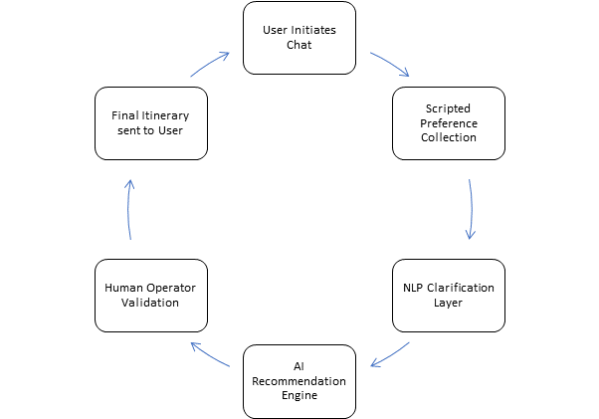
Figure 3: Chatbot Taxonomy and Recommended Hybrid Flow for Htundla (Scripted Core + NLP Clarifier)

Table 2: Comparison of Chatbot Design Choices for Tourism Applications
S/N | Chatbot Type | Implementation Cost | Data Requirements | Localization Complexity | Recommended Fit (Safari vs. MICE)
1 | Rule-Based (Scripted Decision Trees) | Low cost (simple flows, minimal ML) | Minimal data; only predefined questions/answers | Low -translations and phrasing updates only | Safari: Good for basic queries; MICE: Not flexible enough for diverse event needs
2 | Retrieval-Based (Intent Classification + Response Bank) | Moderate cost (requires training an intent model) | Medium - needs labelled intents, sample utterances | Medium - requires language model tuning; must cover local idioms | Safari: Useful for mid-level queries; MICE: works but limited for custom events
3 | Hybrid Chatbot (Scripted Core + NLP Clarifier) | Moderate - High (scripted flows + ML components) | Medium - requires both structured scripts and NLP training data | Medium - High, but scalable; supports multilingual inputs | Safari: Ideal for guided preference collection; MICE: Handles complex requirements and clarifications
4 | Generative Chatbots (LLMs / AI Agents) | High (compute + safety monitoring) | High - requires large datasets for domain tuning | High - must handle multiple languages, safety checks | Safari: High risk of hallucinations; MICE: Not recommended for cost-sensitive context

2.4.3 Case 3: An Integrated Recommender System for Multi Day Tourist Itineraries
Case Description
Ghobadi et al. (2023) present an integrated system that predicts tourist interests and constructs feasible multi-day itineraries by combining preference modeling with constraint-aware planning. The study addresses the two core problems of itinerary recommendation:
- Estimating user interest scores for points of interest (POIs) from sparse signals
- Sequencing POIs into day-by-day plans that respect temporal, spatial, and operational constraints (opening hours, travel time, daily fatigue limits).
The system is explicitly engineered to move beyond single-item recommendation and toward practical itinerary generation that visitors can use as a ready plan (Ghobadi et al., 2023).
Operationally, the pipeline consists of:
- Preference inference; where the system uses user profiles and historical behavior to predict interest weights for candidate POIs.
- POI scoring and clustering; which groups attractions by similarity, theme, and geographic proximity.
- Constraint-aware sequencing; where a solver (exact or heuristic) assembles POIs into daily blocks while minimizing travel time and maximizing overall interest score. The authors evaluate their model on realistic datasets and report improvements over baseline ranking methods when measured by itinerary coherence and user satisfaction proxies (Ghobadi et al., 2023)

System Architecture
A canonical architecture emerging from Ghobadi et al. and related work uses three layers:
- Preference and Context Module - ingests user preferences (explicit and implicit), temporal constraints, and contextual signals (season, weather).
- POI Representation and Similarity Module - encodes POIs using textual descriptions, categories, and geographic coordinates; similarity may use TF-IDF, embedding models, or hybrid metrics.
- Itinerary Planner / Constraint Solver - applies optimization techniques (e.g., greedy heuristics, metaheuristics, or exact VRP/TSP variants with time windows) to allocate POIs across days. Evaluation uses both offline metrics (coverage, distance, constraint violations) and online user tests.
Strengths
- End-to-end itinerary generation: Unlike package rankers, the system produces ordered multi-day plans that visitors can follow, addressing a key user need for actionable schedules.
- Constraint awareness: By integrating time windows, opening hours, and travel time into planning, the system yields feasible itineraries rather than idealized lists. This practical realism increases usability.
- Hybrid modelling of preferences and POI features: The combination of preference prediction (collaborative/supervised) with content/geo similarity enables personalized and locally coherent itineraries.
- Demonstrated empirical gains: The paper reports better coherence and user-oriented metrics than baseline ranking approaches, suggesting measurable benefit from integrated planning.

Weaknesses
- High Data and metadata requirements: Multi-day planners need rich POI metadata (opening hours, travel times, categories) and often historical user-interaction logs - resources many small operators lack.
- Computational complexity: Sequencing POIs under multiple constraints is computationally intensive; many implementations resort to heuristics or metaheuristics (ACS, GA, etc.), which may produce suboptimal but acceptable solutions. This increases implementation complexity and maintenance cost.
- Domain specificity: Systems tuned for urban sightseeing or cultural tourism may not transfer cleanly to safari or MICE contexts, where POIs are lodges, game drives, or conference venues with different constraint profiles (vehicle availability, game-viewing windows, event room booking).
- User-interaction demands: Effective itinerary planners often require user feedback loops (accept/reject/adjust), which complicates UI/UX design and evaluation. Without these loops, recommendations risk being mismatched to transient user needs (Erbil & Wörndl, 2021).

Identified Gap
Although Ghobadi et al. furnish a powerful framework for multi-day itinerary creation, there is a practical gap for single-operator, low-data deployments serving specialized domains like safari and MICE. Specifically:
- POI metadata scarcity for safari/MICE: Safari operations depend on lodge schedules, game drive timings, and park regulations; MICE requires venue availability, room setups, and AV logistics. These data types are not the focus of generalized POI datasets used in the paper.
- Operational handoff for pricing and logistics: The Ghobadi system automates sequencing but does not prescribe a human-in-the-loop step for cost validation or vendor negotiation - a crucial requirement when itinerary feasibility depends on operator capacity and pricing.
- Simplified optimization expectations: Many academic systems assume access to real road networks and accurate travel times; in practice (e.g., Kenyan parks), road conditions and seasonal access may invalidate naïve travel time assumptions.
Therefore, while Ghobadi et al. point the way to feasible itinerary automation, Htundla Safaris must adapt the approach to (a) operate with lean POI metadata, (b) produce day-by-day activity lists (rather than fully optimized VRP solutions) to reduce computational and data requirements, and (c) route outputs to a human operator for pricing and operational confirmation Ghobadi et al. (2023) and Hendrawa et al. (2024) .

Relevance to Htundla Safaris
- Adopt simplified itinerary generation: Use Ghobadi’s preference modelling and POI clustering but constrain the planner to produce activity-per-day suggestions (a lightweight compromise) rather than full VRP optimization. This reduces compute and data needs while delivering immediate user value (Ghobadi et al., 2023)

- Design for sparse metadata: Build the system to work with minimal metadata (activity type, rough duration, best time/day) and allow the operator dashboard to enrich or correct POI details. This human augmentation compensates for limited datasets.

- Integrate HITL for logistics and pricing: Route automated itineraries into an operator validation workflow where staff confirm availability, adjust sequencing for vehicle logistics, and produce the final cost sheet—closing the practical gap left by Ghobadi et al (2023).

Figure 4: Multi-Day itinerary generation flow

Table 3:Comparison Between the Ghobadi et al. (2023) System and the Proposed Htundla System
Criteria | Ghobadi et al. (2023) | Proposed Htundla System
Data Needs | Requires detailed POI metadata (opening hours, travel times, historical user behaviour) | Works with lean metadata (activity type, duration, time-of-day range) and adds operator enrichment
Output Type | Fully sequenced multi-day itinerary optimized for coherence | Per-day recommended activities list, subject to operator customization
Optimization Complexity | High - relies on VRP/TSP-like solvers or heuristics | Moderate - simplified sequencing and clustering algorithms
HITL Presence | None; itinerary generation is automated | Strong - operator reviews itinerary and generates pricing
Domain Suitability | Urban sightseeing, cultural tourism | Safari tours, lodge-based experiences, MICE event planning

2.4.4 Case 4: GEVR: A Group Event Venue Recommendation System
Case Description
The GEVR system, developed by Zhang et al. (2019), is a recommendation engine tailored to groups of mobile users planning a meeting or event. Rather than recommending venues to a single individual, GEVR models the mobility patterns and social relationships of multiple people to predict where a group is likely to convene and which venue best serves them.
To build this, the authors used real-world data from the OutWithFriendz mobile app, which logs group event planning activities, together with individual location traces. They classify the strength of social relationships among group members and adapt their decision strategy based on this, for example, closer friends may have different meeting behavior compared to loosely connected colleagues. After aggregating individual preferences and predicted meeting clusters, GEVR integrates with the Foursquare Venue Recommendation API to suggest venues that minimize travel inconvenience while satisfying group members.

System Architecture
- Group Mobility & Decision Modelling: GEVR first predicts where a group will meet by modelling each member’s location preferences, using individual mobility traces and social relationship strength.

- Venue Candidate Generation: It then retrieves a candidate set of venues from Foursquare based on geographic clusters and group location prediction.

- Group Scoring & Recommendation: Venues are scored based on aggregated group preference, mobility cost, and social consensus. The system applies different decision strategies depending on how “close” the group is socially (strong ties vs weak ties).

- Output & Feedback: The system presents a ranked list of suggested venues for the group to review and finalize, ideally balancing location convenience and group satisfaction.
Strengths
- Group-Aware Recommendation: GEVR explicitly models group dynamics and social relationships, not just individual preferences; this improves the relevance of recommendations for collective decision-making.
- Mobility-Driven Predictions: By leveraging location traces, the system understands where each member is likely to convene, thus minimizing travel inconvenience.
- Cold-Start Robustness: The authors report strong performance even when group prior data is minimal, thanks to their adaptive decision strategies.
- Real-World Integration: The system connects to Foursquare for live venue data, making its recommendations practically usable and context-aware.

Weaknesses
- Data Privacy Concerns: The use of continuous location traces raises privacy and consent issues, which may hinder adoption among corporate clients or in regulated contexts.
- Dependency on External API: GEVR relies on Foursquare for venue information; if the API is limited or unavailable for a region (e.g., certain Kenyan venues), the system’s value diminishes.
- Scalability to Niche Venues: Foursquare may not list very specialized venues (safari lodges, private conference spaces), limiting the system’s applicability for MICE + safari combinations.
- No Cost Negotiation Layer: While GEVR recommends venues, it does not handle booking, pricing negotiation, or validation by a human, which is critical in a full-service tour operator context.

Identified Gap
Although GEVR represents a sophisticated solution for group-based venue recommendation, it does not address specialized MICE + experiential tourism scenarios where event venues should be bundled with safari or activity packages. It also lacks a human-in-the-loop mechanism for validating cost, confirming bookings, or negotiating availability, key business functions for a tour operator. For Htundla Safaris, these gaps mean GEVR’s core architecture needs standalone adaptation: integrating experiential (safari) recommendations and a manual validation workflow for pricing and logistics.

Relevance to Htundla Safaris
- Venue + Experience Bundling: Htundla can build on GEVR’s venue recommendation logic but extend it to suggest combined safari + event offers (e.g., a conference at Nairobi hotel + game drives).
- Operator Validation Layer: Incorporate a human validation module where Htundla's staff refine the automated venue recommendations, check availability, and finalize cost packages.
- Data Strategy: Since location-trace data may not be available for all clients, Htundla can allow manual input of delegate locations or use simpler clustering, leveraging GEVR’s group decision strategies without heavy mobility tracking.

Figure 5: GEVR Recommendation Flow for Groups

Table 4: GEVR vs Htundla Venue + Safari/MICE Recommendation System
Criteria | GEVR System | Proposed Htundla System
Group decision model | Uses social strength + mobility | Uses social strength; manual override by operator
Venue data source | Foursquare + location traces | Local and global venues + safari lodges + MICE venues
Validation | AI-driven, no human layer | Human validation for cost and availability
Privacy risk | High (location tracking) | Reduced - optional location input, operator review
Domain alignment | General venues | Bundled conference + safari packages

2.4.5 Case 5: SafariBooking.com Recommender and Trip-Planning Platform
Case Description
SafariBooking.com is one of the largest global digital platforms for African safari travel planning, used to compare tour operators, browse safari packages, and discover destinations across Kenya, Tanzania, Uganda, and southern Africa. The system provides structured package information (itinerary, accommodation type, activities, price range), wildlife expectations, operator profiles, and reviews. It also includes a semi-automated recommendation engine that filters packages based on user-selected preferences such as country, duration, budget range, and safari type (luxury, mid-range, camping, migration safari, Big Five safari, etc.) (SafariBookings, n.d.).
While not purely “AI-powered,” SafariBooking uses heuristic-driven filtering, popularity scoring, user reviews, and categorical matching to improve relevance. It also provides interactive tools that estimate best travel seasons, wildlife visibility predictions, and compare different itineraries day-by-day.
SafariBooking aggregates data from more than 1,700 safari operators and 4,500 packages worldwide (SafariBookings, n.d.). This gives the system a massive real-world dataset that many AI tourism prototypes do not have, allowing it to evaluate trends such as seasonal pricing, visibility of wildlife, most-booked destinations, and user reviews. Users can perform side-by-side comparisons of itineraries and get automated suggestions for “similar safaris” based on shared attributes (destination, accommodation class, group size, and wildlife type).

System Architecture
SafariBookings operates on a multi-tier architecture designed for large-scale safari data aggregation and rule-based tour filtering. The platform’s backend includes a central package repository populated by over 1,700 operators, storing structured metadata such as destination, pricing, itinerary details, wildlife visibility, accommodation class, and operator reviews. This repository supports efficient querying and comparison.
A rule-based recommendation engine processes user-selected filters (budget, duration, country, accommodation level), combining them with heuristic scoring factors like operator reputation and package popularity. Unlike AI-driven systems, recommendations rely on predetermined rules rather than learned user patterns.
The front-end interface enables browsing, multi-package comparison, and operator profile viewing. User inquiries are routed to operators through a communication layer that supports manual follow-up but offers no automated itinerary customization or pricing.

Strengths
- Large-Scale, Real-World African Data:
SafariBooking is built on thousands of safari packages and millions of user data points, giving it unmatched coverage of Kenya’s tourism ecosystem, significantly more comprehensive than any academic prototype.
- Effective Multi-Criteria Filtering:
Its rule-based filtering combines destination, safari type, cost, operator rating, wildlife visibility, and seasonality. This naturally mirrors the criteria used by tourists and simplifies the decision-making process.
- High Trust Through Operator Reviews & Transparency:
The platform integrates verified operator reviews, comparison tools, and detailed itineraries, which help tourists build trust, especially international clients who cannot verify operators manually.
- Context-Specific Relevance to Safari Tourism:
SafariBooking is tailored specifically to African safaris, unlike generic travel recommenders that focus on hotels or restaurants.

Weaknesses
- No Conversational Interface:
SafariBooking does not include a chatbot or conversation-driven preference gathering. Users must manually select filters, making the experience more mechanical and less personalized.
- Limited Personalization Logic:
Recommendations are based primarily on category filters and popularity. There is no learning mechanism (e.g., content-based similarity using NLP) that understands why a user prefers certain activities or experiences.
- No Local Operator Integration Layer:
The system lists operators globally but does not allow individual Kenyan SMEs to integrate custom itineraries dynamically or provide real-time pricing adjustments.
- Static Itinerary Structure:
Itineraries are fixed and cannot be personalized automatically, a major limitation for a system meant to enhance customized safari planning.

Identified Gap
SafariBooking.com provides extensive safari data and multi-criteria filtering, but lacks the automated personalization, itinerary generation, and chatbot-based preference collection required for dynamic, custom-made trip planning. For Htundla Safaris, this represents a significant opportunity: a system that does not rely on manual filters, but uses conversational input plus hybrid AI techniques (rule-based + TF-IDF + cosine similarity) to generate tailored safari or MICE itineraries and forward them to a human operator for pricing and final adjustments. SafariBookings’ lack of interactive AI, contextual dialogue, and real-time customization marks a clear gap your system is designed to fill.

Relevance to Htundla Safaris
Htundla can replicate SafariBookings’ strengths (structured safari package representation, seasonal intelligence, wildlife expectations), but improve on it through:
  - Chatbot-driven preference acquisition
  - Automated personalization beyond static filters
  - Dynamic itinerary assembly
  - Human-in-the-loop price validation
  - Integration of MICE + safari bundles
This positions the system not just as a copy of SafariBooking, but a next-generation intelligent interface customized for a single operator.

Figure 6: SafariBooking Recommendation Flow

Table 5: Comparison of SafariBooking vs. Proposed Htundla System
Criteria | SafariBooking.com | Proposed Htundla System
User Input Mode | Manual filters | Conversational chatbot
Personalization | Static filters + popularity | Automated hybrid recommender
Itinerary Customization | Fixed itineraries | Automatically generated per-user
Pricing | Static listing | Human operator validation
Domain | Africa-wide operators | Single operator, Kenya-focused + MICE
Recommendation Logic | Heuristic filtering | TF-IDF + cosine similarity + rules

2.4.6 Case 6: DTCRSKG: A Deep Travel Conversational Recommender System Incorporating a Knowledge Graph
Case Description
DTCRSKG, developed by Fang et al. (2022), is a deep-learning–based conversational travel recommender that integrates a knowledge graph (KG) into a multi-turn dialogue system to deliver personalized itinerary suggestions. The system aims to address the limitations of traditional recommendation systems that fail to capture conversational context, user preference evolution, and semantic relationships between travel entities.
The model incorporates dialogue history, entity embeddings, and preference inference to refine recommendations during the conversation. As users interact with the chatbot and express interests (e.g., “I want beaches,” “Prefer cultural sites,” “I have 4 days”), the system retrieves structured travel knowledge from the KG and updates its internal preference vector. DTCRSKG uses a combination of graph convolutional networks (GCN) and RNN-based dialogue encoders to represent user intent and travel concepts, enabling rich semantic matching between user input and travel items.

System Architecture
The architecture of DTCRSKG is organized into four primary modules:
- Dialogue Understanding Module
Uses RNN-based or transformer-like encoders to process multi-turn interactions. The system captures user intents, context dependencies, and evolving preference signals across multiple conversation turns.
- Knowledge Graph Integration Layer
Integrates a travel-domain knowledge graph storing relationships among POIs, activities, destinations, seasons, categories, and user interests. GCNs propagate semantic information through the graph to enrich the embeddings used for recommendation.
- Preference Inference Model
Combines outputs from the dialogue encoder and KG embeddings to maintain a dynamic preference representation. The model continually updates user preferences as new conversational cues appear.
- Recommendation Generation Layer
Uses a ranking model to compare user preference embeddings with all travel-item embeddings (e.g., destinations, attractions). The system generates a list of recommended items that align with the most recent inferred preferences.

Strengths
- Conversational, Multi-Turn Personalization:
DTCRSKG evolves recommendations through dialogue rather than static filtering, allowing highly personalized and context-aware results.

- Knowledge Graph Contextualization
The KG enhances semantic understanding of travel preferences, enabling the system to infer deeper relationships (e.g., “beach + culture,” “mountains + wildlife”).

- Improved Cold-Start Handling
The model mitigates sparse user data issues by inferring preferences from conversational patterns and KG relations.

- Strong Empirical Performance
Experimental results show DTCRSKG outperforms baseline travel recommenders in accuracy and relevance metrics.
Weaknesses
- High Computational Overhead:
KG embedding generation and multi-turn conversation modelling require significant computing and deep learning expertise.

- Data-Intensive Training Requirements
The system depends on large, high-quality travel dialogues and KG datasets, which may not exist for regions like Kenya without costly data curation.

- No Integration with Human Operators
Pricing validation, availability confirmation, and operator negotiation, crucial in real safari/MICE workflows, are not supported.

- Not Designed for Safari/MICE Contexts
The KG is optimized for general tourism rather than safari itineraries, lodge logistics, or conference venues.
Identified Gap
DTCRSKG excels in conversational, KG-aware trip recommendation but does not address the hybrid automation + human workflow required for safari-based operators in Kenya. The system also lacks domain-specific knowledge graphs for wildlife conservation areas, MICE venues, and safari logistics unique to East Africa. Moreover, it does not support pricing validation or human-in-the-loop correction, both essential for operators like Htundla Safaris. This positions Htundla’s hybrid model, chatbot + rule-based logic + TF-IDF + cosine similarity + human pricing, as a more deployable and context-appropriate solution for the Kenyan tourism ecosystem.

Relevance to Htundla Safaris
- DTCRSKG offers design inspiration for multi-turn preference inference, which Htundla can emulate using a simpler rule-based and content-based approach.
- The knowledge-graph idea can be adapted into lightweight metadata structures for safari packages and MICE venues.
- The lack of human oversight in DTCRSKG highlights the importance of Htundla’s operator validation module.
- Shows how conversational grounding significantly improves recommendation accuracy, strengthening the justification for a chatbot interface.

Figure 7: DTCRSKG System Workflow
Table 6: DTCRSKG vs. Proposed Htundla System
Criteria | DTCRSKG | Proposed Htundla System
Input Method | Multi-turn conversation | Multi-turn chatbot
AI Mechanism | Deep learning + knowledge graph | Hybrid (Rule-based + TF-IDF + cosine similarity)
Domain | General tourism | Kenya safaris + MICE
Itinerary Generation | List of items | Full itinerary + human refinement
Pricing | Not supported | Human validated
Deployment Complexity | High | Moderate
Data Needs | Large KG + training sets | Small curated datasets

2.4.7 Kenyan Tourism Industry Chatbot Pilots (Non-Peer Reviewed Evidence)
Although Kenya lacks peer-reviewed academic tourism chatbots, several industry pilots demonstrate the sector’s shift toward automated digital customer support:
- Kenya Tourism Board (KTB) Digital Initiatives:
KTB has launched multiple digital campaigns aiming to automate visitor engagement and integrate content discovery tools for tourists, reflecting growing national interest in AI-driven tourism support.
- Safari Industry AI Assistants:
Industry reports highlight Kenyan tour operators experimenting with AI-based customer assistants, designed to answer basic questions about destinations, park fees, and travel logistics (Ministry of Tourism and Wildlife, 2025). These tools primarily focus on reducing inquiry load and improving initial customer engagement efficiency. Reports highlight AI's potential in personalizing travel, streamlining operations, and enabling data-driven decision-making (Ministry of Tourism and Wildlife, 2025).

Relevance to Htundla
- Confirms that the Kenyan market is moving toward automated support.
- Shows that real operators struggle with the same problems the proposed system is trying to solve; manual inquiries, slow responses, and lack of personalization.
- Supports the justification that a fully conversational + automated + human-supervised system is needed.

2.6 Emerging Trends and Patterns
A review of the six systems reveals several consistent trends shaping the evolution of automated tourism technologies.
First, conversational interfaces are emerging as the preferred method for gathering user preferences in travel systems. Multi-turn dialogue enables more precise personalization compared to static filtering, aligning with user expectations for natural, interactive planning tools. Systems like DTCRSKG demonstrate this shift effectively.
Second, hybrid recommendation architectures, combining rule-based logic, content-based filtering, collaborative filtering, or knowledge-graph embeddings, are becoming dominant. These models outperform single-technique recommenders by addressing limitations like cold-start problems and sparse user data. Case studies by Nagababu et al. and Ghobadi et al. show how hybridization improves accuracy in destination selection and itinerary sequencing.
Third, emerging systems increasingly incorporate contextual and semantic intelligence through knowledge graphs, metadata-rich datasets, and geo-context features. DTCRSKG integrates semantic travel relationships, while MICE-oriented systems like GEVR use mobility context and social modelling to enhance group-based venue recommendations.
Fourth, there is growing emphasis on user experience and decision-support tools. SafariBookings' large-scale package database and comparison engine exemplify this trend, prioritizing transparency, trust-building, and structured information delivery for high-value tourist decisions.
Finally, Human-in-the-loop (HITL) patterns are gaining traction in real-world tourism operations, particularly where dynamic pricing, limited APIs, and manual logistics dominate. The African safari ecosystem especially requires expert intervention for itinerary customization and pricing validation, making HITL essential despite many academic systems overlooking operator involvement.

2.7 Research Gap
Despite advancements in conversational travel assistants, hybrid recommenders, and itinerary optimization systems, several gaps persist, particularly in the context of Kenya’s safari and MICE tourism sector. Existing automated systems either focus on generalized travel recommendations (DTCRSKG), venue suggestions for urban events (GEVR), or static safari package filtering (SafariBookings), but none deliver a unified system that combines conversational preference elicitation, dynamic safari/MICE itinerary generation, and human operator validation within a Kenya-specific context.
Current chatbot systems for tourism are limited to information retrieval rather than intelligent, personalized itinerary creation, while most itinerary generation studies prioritize algorithmic optimization over practical deployability in regions where data sparsity, unstable APIs, and manual pricing workflows are common. Likewise, MICE recommendation research emphasizes venue suitability but does not integrate leisure extensions like safaris, which are crucial components of Kenya’s tourism value proposition.
Additionally, no reviewed system incorporates a hybrid architecture that blends rule-based reasoning, TF-IDF similarity, and content-based algorithms while also supporting operator-mediated refinement. This creates a clear gap for a solution capable of generating personalized safari and MICE itineraries from conversational input, supported by lightweight automated models and integrated with human expertise for final pricing and logistical accuracy.
The research gap therefore centers on the absence of a domain-specific, conversational, hybrid itinerary recommender tailored to Kenya’s safari and MICE ecosystem, capable of balancing automation with operator oversight. The proposed Htundla Safaris system directly addresses this gap.

2.8 Chapter Summary
This chapter presented an in-depth review of literature related to conversational tourism systems, hybrid recommendation algorithms, itinerary generation models, MICE venue recommenders, and safari-focused digital platforms. Six case studies were analyzed to examine their architectures, strengths, weaknesses, and relevance to the proposed system. Across these cases, several trends emerged, including the rise of conversational interfaces, hybrid recommendation models, knowledge-graph-enhanced personalization, and the need for human-in-the-loop validation in real-world tourism scenarios.
The analysis revealed several significant shortcomings in the current systems, including the inability to create customised safari itineraries, the lack of integrated MICE-safari bundling, the inadequate support for logistics unique to Kenya, and the restricted methods for human operator involvement in pricing and availability verification. These shortcomings underscore the need for a domain-specific solution that supports dynamic, context-aware tour planning by utilising conversational AI, hybrid recommendation logic, and expert supervision.
The suggested automated tour recommendation system for Htundla Safaris was designed using the knowledge gained from this literature review. The methodology used to fill the identified research gap and direct the system's development will be presented in the following chapter.

CHAPTER THREE: METHODOLOGY

3.1 Introduction
This chapter outlines the methodological approaches, tools, and techniques used in the development of the automated tour recommendation system for Htundla Safaris. The chapter details the procedures used for requirements elicitation, system analysis, system design, implementation, testing, and deployment. The methodology choices align with standard system development practices and ensure a structured, traceable progression from problem identification to system realization.

3.2 Methodology of Requirement Elicitation
A qualitative requirements elicitation approach was adopted to gather system requirements from the perspective of tour operators and potential system users.
Techniques Used
The following techniques were applied, in order of importance:
- Interviews
Semi-structured interviews were conducted with individuals familiar with tour operations to understand:
  - Common customer inquiries
  - Manual itinerary preparation processes
  - Challenges in responding to client requests

- Document Review
Existing tour company websites, brochures, and sample itineraries were reviewed to identify:
  - Typical package structures
  - Commonly offered safari and MICE services
  - Information gaps in online platforms

- Observation
Informal observation of how tour inquiries are handled through email and messaging platforms (e.g., WhatsApp) informed the conversational flow of the proposed system.
The elicited requirements were consolidated, analysed, and categorized into functional and non-functional requirements.

3.3 Methodology for System Analysis
The study adopts the Structured Systems Analysis and Design (SSAD) methodology.
SSAD was selected because:
- It is well-suited for data-driven systems
- It emphasizes clarity in system processes and data flows
- It aligns with academic system documentation standards
The following SSAD tools were employed consistently for both the current and proposed systems:
- System Workflow Diagrams – to represent the sequence of operations
- Context Diagram – to define system boundaries and external entities
- Data Flow Diagrams (DFD Level 1 and Level 2) – to illustrate data movement and processing
- Data Normalization (up to Third Normal Form) – to structure database entities and remove redundancy

3.4 Methodology for System Design
The system design phase also followed the SSAD approach, ensuring consistency with the analysis phase. Design activities transformed analysis outputs into technical structures and system components.
Design Tools and Techniques:
- Flowcharts:
Used to illustrate key system processes such as the chatbot conversation flow, itinerary generation logic, and operator validation process.
- User Interface Design:
UI/UX wireframes and prototypes were created to outline the layout of the chatbot interface, itinerary display screens, operator dashboard, and recommendation results pages.
- Database Design Using ERD:
Entity-Relationship Diagrams were employed to model logical and physical database structures aligned with normalized tables.
- Architectural Modelling (Informal):
High-level architecture descriptions were used to define the frontend–backend–automation module integration using Django, and the Python recommendation engine.

3.5 Methodology for System Implementation
A modular and incremental implementation approach was adopted. Each system component was developed and tested independently before integration.
Tools and Technologies Used:
  - Frontend
- HTML - for structuring web pages
- CSS - for basic styling and layout
- JavaScript - for minimal client-side interactivity

  - Backend
- Python - primary programming language
- Django Web Framework - for handling:
- Application logic
- Routing
- User requests
- Template rendering

  - Database
- SQLite - used during development for simplicity
- MySQL - proposed for production-level deployment

  - Automation Recommendation Logic
- Scikit-learn - used to implement:
- TF-IDF vectorization
- Cosine similarity computation
- Custom Python Functions - to rank destinations and activities

The automation component is implemented as a decision-support module, generating draft itineraries rather than final bookings.

3.6 Methodology for System Testing
System testing followed a structured testing process to ensure system correctness, reliability, usability, and alignment with user requirements.
Testing Approach:
- Test Data Generation - Synthetic test data and sample safari/MICE package records were created to validate system behaviour under different user preference scenarios.

- Testing Techniques:
- Black-box testing: To verify functionality without focusing on internal code structure.
- White-box testing: Applied selectively to core automated logic.
- Unit testing: Ensured individual modules (chatbot input handling, recommendation engine, API endpoints) behave as expected.
- Integration testing: Validated smooth communication between the frontend, Django backend, and automation module.
- User acceptance testing (UAT): Performed with selected tour operators to confirm usability and practical relevance.

- Testing Plan - Defined expected inputs, outputs, procedures, and pass/fail criteria for each functionality tested.

3.7 Methodology for System Deployment
Deployment methodology focuses on introducing the system to real users in a controlled and risk-mitigated manner.
A Pilot Deployment approach was selected due to the need for operator training, iterative refinement, and cost-sheet validation workflows.
Deployment Activities:
- Data Migration Plan:
- Importing initial safari and MICE package templates
- Creating user accounts for operators
- Loading reference data required for recommendation processing

- User Training:
- System walkthrough sessions for tour operators
- Training on managing itineraries, validating automated outputs, and responding to chatbot-initiated inquiries
- Documentation provided including user manual and admin guide

- Feedback & Iteration:
- Collecting pilot feedback
- Refining conversational flows and recommendation weighting parameters
- Addressing usability or performance issues

3.8 Chapter Summary
This chapter has outlined the methodologies used in the development of the automated tour recommendation system for Htundla Safaris. The chapter explained the approaches applied in requirement elicitation, system analysis, system design, implementation, testing, and deployment. SSAD was adopted as the primary analytical and design framework, supported by structured data collection and well-defined implementation, testing, and deployment strategies. The methodologies described here form the foundation for the detailed system analysis and design presented in subsequent chapters.

CHAPTER FOUR: SYSTEM ANALYSIS

4.1 Introduction
This chapter presents a detailed analysis of both the existing tour inquiry system and the proposed automated tour recommendation system for Htundla Safaris. The analysis is conducted using the SSAD approach to ensure clarity in understanding system processes, data flows, and user interactions. The chapter begins by examining the current manual system to identify its limitations, followed by a feasibility study and comprehensive requirements analysis for the proposed system. Finally, the proposed system is analyzed through workflows, data flow diagrams, user roles, and data normalization to establish a solid foundation for system design and implementation.

4.2 Description of the Current Systems
Htundla Safaris, like many small and medium-sized tour operators in Kenya, primarily relies on manual and semi-digital processes to handle customer inquiries and tour planning. Customer interactions are initiated through email, phone calls, social media platforms, or messaging applications such as WhatsApp. Tour information is typically presented through static websites or brochures that list generic tour packages.
When a customer makes an inquiry, a tour operator manually collects preferences, drafts an itinerary, computes costs, and responds to the client. This process is repeated for each customer, regardless of similarity in preferences, leading to inefficiencies and delays.

4.2.1 Current System Workflow

Figure 8: Current System Workflow

4.2.2 Current System Context Diagram
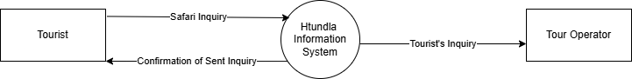
Figure 9: Current System Context Diagram

4.2.3 Current System Data Flow Diagram (DFD-Level 1)

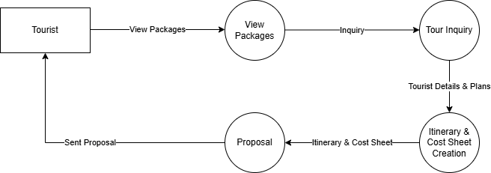
Figure 10: Current System DFD (Level 1)

4.2.4 Current System Strengths
- Direct human interaction which enhances trust and flexibility.
- Low technological overhead.
- Operators can apply judgement based on context and experience.

4.2.5 Current System Weakness
- Slow response time to customer inquiries especially during high seasons.
- No personalization automation.
- Repetitive manual work for similar customer requests.
- Poor scalability during peak seasons.
- Lack of structured data for analytics and learning.

4.3 Feasibility Study
A feasibility study was conducted to determine the practicality of implementing the proposed system.

4.3.1 Operational Feasibility
The proposed system aligns well with existing tour operations. It does not replace human operators but offers support by automating repetitive tasks. Staff training requirements are minimal, making the system operationally viable.

4.3.2 Technical Feasibility
The system utilizes widely adopted and well-documented technologies including HTML, CSS, JavaScript, Python, Django, and MySQL. The automation component is limited to basic content-based recommendation techniques, ensuring feasibility within available technical skills and resources.

4.3.3 Social Feasibility
The system supports human-centered service delivery by retaining the tour operator’s role in pricing and final booking decisions. Customers benefit from faster responses while still engaging with a human representative, making the system socially acceptable.

4.3.4 Economic Feasibility
The system is cost-effective due to the use of open-source tools and frameworks. Development and maintenance costs are minimal, and the system has the potential to increase conversion rates and reduce operational workload.

4.4 Requirements Analysis
Requirements were gathered using interviews, document reviews, and observation, as outlined in Chapter Three. The collected data was aggregated and analysed to identify system needs, which were categorized into functional and non-functional requirements.

4.4.1 Functional Requirements
The system shall:
- Allow users to interact with a chatbot via a web interface
- Collect user preferences (destination type, activities, duration, travel style)
- Generate draft itineraries based on user inputs
- Recommend safari and MICE activities relevant to user preferences
- Store user inquiries and generated itineraries in a database
- Allow tour operators to review, edit and finalize itineraries
- Enable operators to generate final cost sheets manually

4.4.2 Non-Functional Requirements
The system shall:
- Be easy to use and understand
- Provide responses within reasonable time
- Be accessible through standard web browsers
- Ensure basic data security and confidentiality

4.5 System Analysis
The proposed system is analysed using SSAD tools to decompose it into logical components and processes.

4.5.1 System Workflow

Figure 11: Proposed System Workflow

4.5.2 Context Diagram
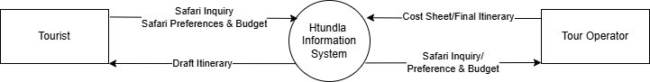
Figure 12: Proposed System Context Diagram

4.5.3 DFD (Level 1)

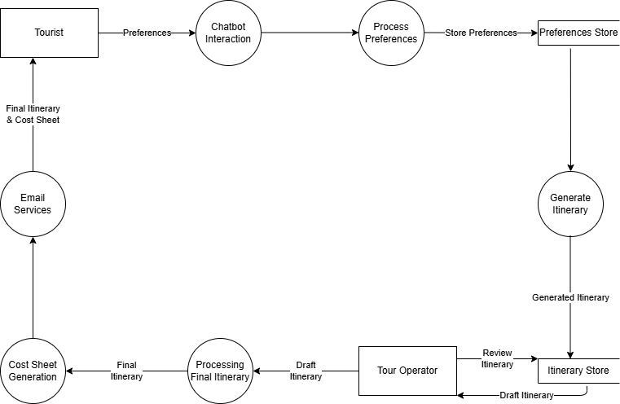
Figure 13: Proposed System DFD (Level 1)

4.5.4 DFD (Level 2)
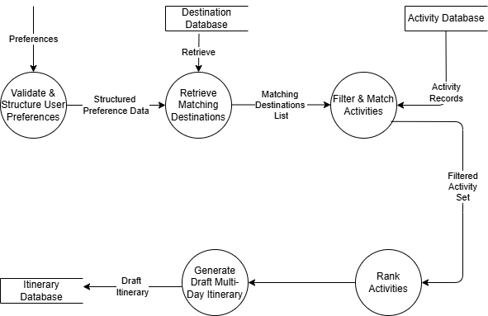
Figure 14: Proposed System DFD (level 2) - Generate Itinerary

4.6 System Users /Actors
Table 7: System Users/Actors
Actor | Inputs | Outputs
Tourist | Preferences/Inquiries | Draft itinerary
Tour Operator | Pricing, Validation | Final itinerary, Cost sheet
System Administrator | Package data | Updated database

4.6 Normalization
This section presents the normalization of data derived from the proposed system. The objective of normalization is to organize data into well-structured relations that reduce redundancy, eliminate anomalies, and improve data integrity. The process was carried out up to Third Normal Form (3NF).
The normalization process is based on the key data identified from the system analysis, including:
- user (tourist) details
- travel preferences (inquiries)
- destinations
- activities
- generated itineraries
- operator responses

Unnormalized Form (UNF)
Initially, the data can be represented in a single unstructured relation as follows:
TOUR_REQUEST
(UserID, FullName, Email, Phone, TravelType, DestinationName, TravelStyle, Duration, GroupSize, Interests, Activity1, Activity2, Activity3, Day1Plan, Day2Plan, Day3Plan, FinalCost, OperatorName, ProposalStatus)
Issues Identified
- Presence of repeating groups (e.g., Activity1, Activity2, Activity3)
- Mixing of different data domains (user data, itinerary data, operator data)
- High Redundancy
- Susceptibility to insertion, deletion and update anomalies

First Normal Form (1NF)
To achieve First Normal Form, all repeating groups were removed and attributes were made atomic.
Resulting Logical Groupings;
- User Information separated from inquiry data
- Activities represented as individual records rather than repeating fields
- Itinerary structure separated from raw inquiry data

Outcome: Each field now contains a single value, and repeating groups are eliminated

Second Normal Form (2NF)
Second Normal Form requires that all non-key attributes depend on the entire primary key.
Adjustments Made;
- Activity details were separated from itinerary records to eliminate partial dependencies
- Destination information was isolated to avoid duplication across inquiries and itineraries
- Operator details were separated from response records

Outcome: All non-key attributes are fully dependent on their respective primary keys, and partial dependencies are removed.

Third Normal Form (3NF)
Third Normal Form requires the removal of transitive dependencies, ensuring that non-key attributes depend only on the primary key.
Adjustments Made;
- Destination details removed from inquiry and itinerary data and stored independently
- User contact details stored only in the user entity
- Operator information separated from proposal response data
- Activity attributes linked only to activity records rather than other entities

Outcome: Each data element is stored in only one place, and all non-key attributes depend solely on the primary key.

4.7 Chapter summary
This chapter analysed both the existing manual tour inquiry system and the proposed automated recommendation system for Htundla Safaris. Through feasibility assessment, requirements analysis, and structured system decomposition, the chapter established a clear understanding of system needs and operations. The findings provide a strong analytical foundation for the system design presented in the next chapter.

CHAPTER FIVE: SYSTEM DESIGN

5.1 Introduction
This chapter presents the design of the proposed system for Htundla Safaris. Building on the analysis in Chapter Four, it shows how the system will be structured to meet the identified requirements and support the main functions of the project.
The chapter focuses on the design of the proposed web-based tour recommendation system, including the user interface, key system processes, database structure, and test data. In simple terms, this chapter moves from understanding the problem to showing how the solution will be organized and how the different parts of the system will work together. The design provided here serves as the guide for the actual development and implementation of the system.

5.2 User Interface Design
This section presents the design of the user interface for the proposed system. Since the system is meant to be simple, clear, and easy to use, the interface focuses on helping users move through the travel inquiry process without confusion. The main goal is to make it easy for a tourist to enter their travel preferences through the chatbot and to view the generated itinerary in a clear and organized way.
The user interface design also considers the needs of the tour operator, who will review the draft itinerary and prepare the final proposal. Overall, this section shows how the system will look from the user’s point of view and how the different screens will support interaction with the system.

5.2.1 Input Form Design
[mockup screens or screenshots of the developed prototype]

5.2.2 Reports Design
[mockup screens or screenshots of the developed prototype]

5.3 Process Design
This section presents the detailed process design of the proposed system. The processes were selected from the proposed system Data Flow Diagram (DFD Level 1) and the Proposed System DFD Level 2 developed in Chapter Four. In line with the SSAD approach adopted in Chapter Three, each selected process is further represented using a flowchart to show the internal sequence of operations and decision points involved in system execution.
The major processes selected for design are: chatbot preference collection, preference validation and structuring, automated itinerary recommendation, and operator review with proposal delivery. These processes represent the core operational logic of the proposed Htundla Safaris system.

5.3.1 Chatbot Preference Collection Process
This process is derived from Process 1: Chatbot Interaction in the Proposed System DFD Level 1 (Figure 13). It represents the first point of contact between the user and the system and is responsible for collecting the travel details required to generate a recommendation.
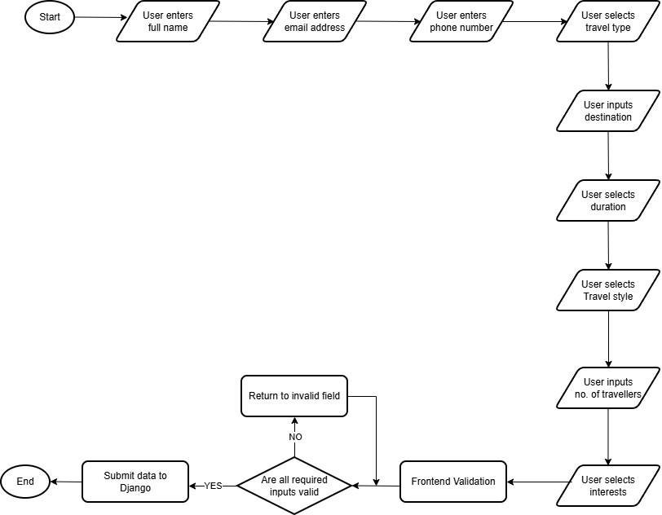

5.3.2 Preference Validation and Structuring Process
This process is derived from Process 2: Process Preferences in the Proposed System DFD Level 1 (Figure 13) and is further supported by the decomposition in the Proposed System DFD Level 2 (Figure 14). It ensures that the submitted chatbot data is accurate, complete, and ready for use by the recommendation module.
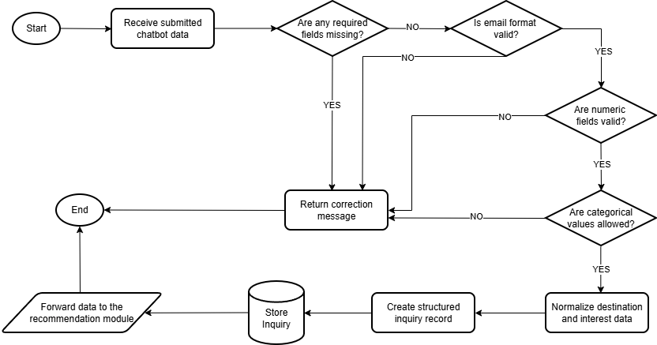

5.3.3 Automated Itinerary Recommendation Process
This process is derived from Process 3: Generate Itinerary in the Proposed System DFD Level 1 (Figure 13) and expanded in the Proposed System DFD Level 2 (Figure 14). It is the main decision-support process in the proposed system.
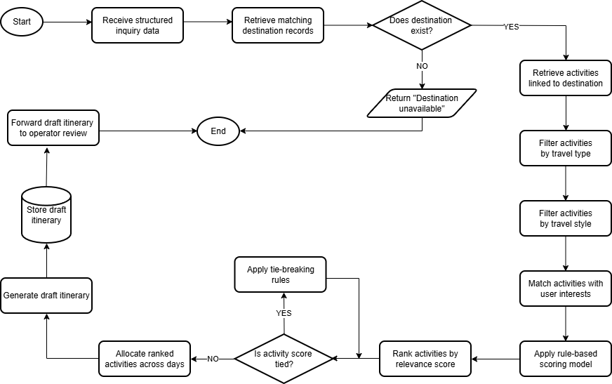

5.3.4 Operator Review and Proposal Delivery Process
This process is derived from Process 4: Operator Review and Process 5: Send Proposal in the Proposed System DFD Level 1 (Figure 13). It represents the human-in-the-loop stage of the system.
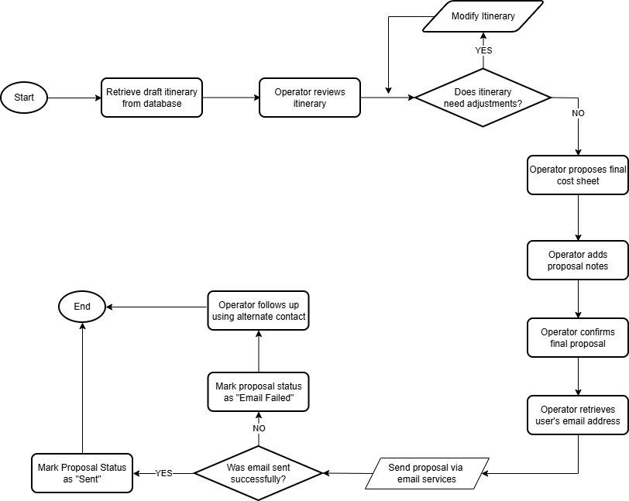

5.4 Database Design
This section presents the database design for the proposed system. The database is important because it is where the system stores the information needed to support the chatbot, generate itineraries, and keep records of customer inquiries and operator responses.
The database design is based on the entities identified during normalization in Chapter Four. It shows how the main pieces of data in the system relate to each other and how they will be organized in a structured way. This section therefore focuses on the Entity Relationship Diagram (ERD) and the data dictionary, which together describe the tables, attributes, and relationships that will support the operation of the system.

5.4.1 Entity Relationship Overview
The system consists of the following eight key entities:
- User - Represents individuals making travel inquiries.
- Inquiry - A travel request submitted by a user, referencing a preferred destination.
- Destination - A travel location with associated categories, descriptions, and seasonal info.
- Activity - A specific activity available at a destination, with cost and style details.
- Itinerary - A compiled travel plan for a user, directly linked to the originating Inquiry.
- Itinerary_Item - An individual activity entry within an itinerary, ordered by day and sequence.
- Operator - A travel operator who reviews itineraries and generates formal proposals.
- Operator_Response - A formal proposal generated by an operator in response to a specific itinerary.

5.4.2 Relationships
The following relationships define how entities interact within the system.
- User → Inquiry (one-to-many) - A User can make multiple Inquiries.
- User → Itinerary (one-to-many) - A User can have multiple Itineraries.
- Inquiry → Itinerary (one-to-one) - An Inquiry results in exactly one Itinerary.
- Destination → Inquiry (one-to-many) - A Destination can be the preferred destination in multiple Inquiries.
- Destination → Itinerary (one-to-many) - A Destination can appear in multiple Itineraries.
- Destination → Activity (one-to-many) - A Destination can have multiple Activities.
- Itinerary → Itinerary_Item (one-to-many) - An Itinerary contains multiple Itinerary_Items.
- Itinerary_Item → Activity (many-to-one) - Each Itinerary_Item references one Activity.
- Operator → Operator_Response (one-to-many) - An Operator generates multiple Operator_Responses.
- Operator_Response → Itinerary (one-to-one) - An Operator_Response reviews one Itinerary.

5.4.3 Data Dictionary
The following tables define all attributes, data types, sizes and descriptions for each entity.
Table 8: USER Table
Attribute | Data Type | Size | Description
UserID | INT | - | Unique Identifier
FullName | VARCHAR | 100 | User’s full name
Email | VARCHAR | 100 | User’s email address
Phone | VARCHAR | 15 | Contact number

Table 9: INQUIRY Table
Attribute | Data Type | Size | Description
InquiryID | INT | - | Unique Inquiry ID
UserID | INT | - | Foreign Key referencing USER
PreferredDestinationID | INT | - | Foreign Key referencing DESTINATION
TravelType | VARCHAR | 20 | Safari or MICE
DurationDays | INT | - | Number of travel Days
TravelStyle | VARCHAR | 30 | Preferred travel style (Budget-friendly, Standard, Luxury)
GroupSize | INT | - | Number of Travellers
Interests | VARCHAR | 255 | Preferred activities
DateSubmitted | DATETIME | - | Date and time the inquiry was submitted

Table 10: DESTINATION Table
Attribute | Data Type | Size | Description
DestinationID | INT | - | Unique identifier
DestinationName | VARCHAR | 100 | Name of destination
Category | VARCHAR | 50 | Safari or MICE
Description | TEXT | - | Destination details
BestSeason | VARCHAR | 50 | Ideal visiting period

Table 11: ACTIVITY Table
Attribute | Data Type | Size | Description
ActivityID | INT | - | Unique identifier
DestinationID | INT | - | Foreign key referencing DESTINATION
ActivityName | VARCHAR | 100 | Name of activity
TravelStyleCategory | VARCHAR | 30 | Suitable travel style: Budget-friendly, Standard or Luxury
ActivityCategory | VARCHAR | 50 | Type of activity
EstimatedDuration | VARCHAR | 20 | Duration: Short, Half-day, Full-day or Multi-Day
TimeSlot | VARCHAR | 20 | Suitable time slot: Morning, Afternoon, Evening, Full-day or Flexible
DaySuitability | VARCHAR | 20 | Suitable day type: Arrival, Mid-trip or Departure
IntensityLevel | VARCHAR | 20 | Activity intensity: Light, Moderate or Heavy
Description | TEXT | - | Activity Details

Table 12: ITINERARY Table
Attribute | Data Type | Size | Description
ItineraryID | INT | - | Unique identifier
InquiryID | INT | - | Foreign key referencing INQUIRY – enforces one to one relationship
DateCreated | DATE | - | Date of creation
NumberOfDays | INT | - | Duration of itinerary
DraftStatus | VARCHAR | 20 | Draft or Final

Table 13: ITINERARY_ITEM Table
Attribute | Data Type | Size | Description
ItineraryItemID | INT | - | Unique identifier
ItineraryID | INT | - | Foreign key referencing ITINERARY
ActivityID | INT | - | Foreign key referencing ACTIVITY
DayNumber | INT | - | Assigned day
AssignedTimeSlot | VARCHAR | 20 | Assigned slot in the day
ActivityOrder | INT | - | Sequence within the day

Table 14: OPERATOR Table
Attribute | Data Type | Size | Description
OperatorID | INT | - | Unique identifier
OperatorName | VARCHAR | 100 | Name of operator
Email | VARCHAR | 100 | Contact email
Phone | VARCHAR | 15 | Contact number

Table 15: OPERATOR_RESPONSE
Attribute | Data Type | Size | Description
ResponseID | INT | - | Unique identifier
ItineraryID | INT | - | Foreign key referencing ITINERARY
OperatorID | INT | - | Foreign key referencing OPERATOR
FinalCost | DECIMAL | - | Final calculated cost
ProposalNotes | TEXT | - | Additional notes
DateFinalized | DATETIME | - | Date proposal was finalized
ProposalStatus | VARCHAR | 20 | Draft/Finalized/Sent

5.4.4 ERD Diagram
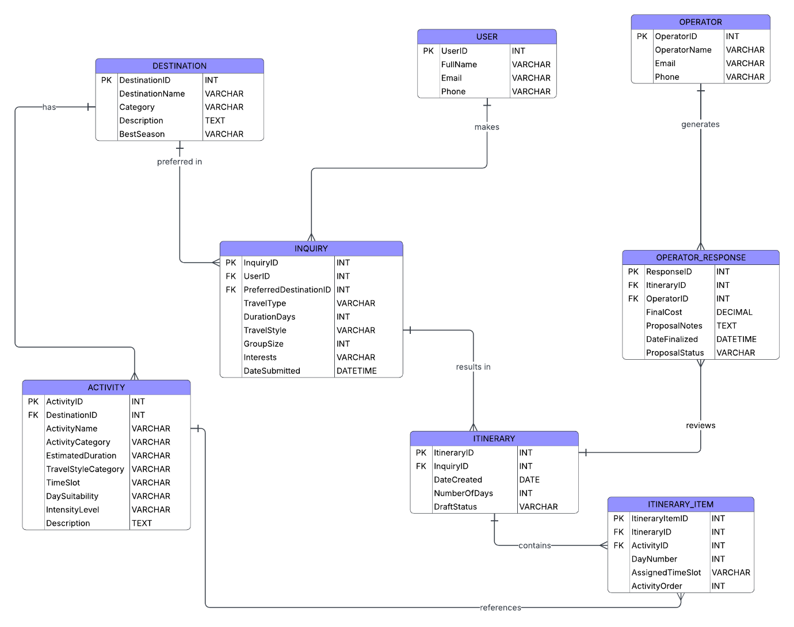

5.5 Test Data
[should be adequate to represent actual input scenario in terms of variance]

5.8 Chapter summary
This chapter presented the system design for the proposed automated tour recommendation system for Htundla Safaris. The design was developed as a direct progression from the system analysis conducted in Chapter Four. The chapter described the user interface structure, process design based on data flow diagrams, and the database design derived from normalized entities.
The database design was structured using a relational model, and a detailed data dictionary was developed to define the attributes, data types, and relationships of all system entities. Additionally, representative test data was created to simulate real-world usage scenarios and validate system functionality.
The system design emphasizes simplicity, modularity, and practical implementation, ensuring that the system remains easy to develop, demonstrate, and evaluate while effectively addressing the identified limitations of the existing manual tour planning process.

CHAPTER SIX: IMPLEMENTATION

6.1 Introduction

6.2 UI Implementation

6.2.1 Input forms Implementation
[screen shots of the developed system]

6.2.2 Reports Implementation
[screen shots of the developed system]

6.3 ERD Implementation
[screen shots from the implemented DB showing the DB structure and table structure] system, the equivalent if using a NO-SQL DB]

6.4 Business Logic Implementation
[Code extract from the client side (e.g form validation) and from the server side (insert, delete, update and select code]

6.5 Module testing
[Test table showing expected versus actual output ro the report generated from given input]
[demonstrable for at least one module]

6.6 Chapter summary

CHAPTER SEVEN: FINDINGS, CONCLUSION AND RECOMMEDATIONS

[order is important. Findings come first, then you conclude based on findings and recommend areas of further study]
[this should be the shortest chapter of all for this level of study]

7.1 Introduction

7.2 Findings

7.2.1 Achievement of objectives
[objectives and requirements if your project was a system]

7.2.1 Challenges
[challenges encountered, that may have hindered achievement of some objectives or requirements]

7.3 Conclusion
[based largely on the state of the developed solution and its applicability]

7.4 Recommendations
[you may have achieved all objectives and requirements, but there are still things you could have done given more time or with an extended scope. This is why you need this section. To recommend that those interested to pursue this research further may consider the items you did not for whatever reasons]

REFERENCES
Camilleri, M. (2023). Chatbot Recommender Systems in Tourism: A Systematic review and a benefit-cost analysis. Chatbot Recommender Systems in Tourism, 1–10. https://www.um.edu.mt/library/oar/bitstream/123456789/105032/1/Chatbot%20recommender%20systems%20in%20tourism%20-%20A%20systematic%20review%20and%20a%20benefit-cost%20analysis.pdf
Erbil, E., & Wörndl, W. (2021). Generating Multi-Day round trip itineraries for tourists. ACM WSDM WebTour, 2855, 1–7. https://ceur-ws.org/Vol-2855/main_short_1.pdf
Fang, H., Chen, C., Long, Y., Xu, G., & Xiao, Y. (2022). DTCRSKG: A Deep Travel Conversational Recommender System Incorporating Knowledge Graph. Mathematics, 10(9), 1402. https://doi.org/10.3390/math10091402
Ghobadi, F., Divsalar, A., Jandaghi, H., & Nozari, R. B. (2023). An integrated recommender system for multi-day tourist itinerary. Applied Soft Computing, 149, 110942. https://doi.org/10.1016/j.asoc.2023.110942
Hendrawa, R., Baiza, Z. K. A., & Septiana Wulandar, G. (2024). Generating a Multi-Day travel itinerary recommendation using the hybrid Ant Colony system and Brainstorm optimization algorithm. International Journal of Intelligent Engineering & Systems, 17(2), 223–234. https://doi.org/10.22266/ijies2024.0430.20
Ministry of Tourism and Wildlife. (2025). The Kenya National Tourism Strategy (2025-2030). In www.tourism.go.ke. https://www.tourism.go.ke/wp-content/uploads/2025/07/DRAFT-NATIONAL-TOURISM-STRATEGY-DRAFT-June-2025-2.pdf
Nagababu, P., Vasavi, G., Sreya Sri, M., & Nikhil, A. (2024). A hybrid recommendation system for personalized travel experiences and enhanced tourism sector efficiency. easychair.org. https://easychair.org/publications/paper/2Hxs
SafariBookings. (n.d.). SafariBookings: Compare 15,578 African Safari Holidays. SafariBookings.com. https://www.safaribookings.com/
Xia, F., Yaw Asabere, N., J.P.C Rodrigues, J., Basso, F., Deonauth, N., & Wang, W. (n.d.). Socially-Aware Venue recommendation for conference participants. https://arxiv.org/pdf/1312.6808
Zhang, J. S., Gartrell, M., Han, R., Lv, Q., & Mishra, S. (2019). GEVR. Proceedings of the ACM on Interactive Mobile Wearable and Ubiquitous Technologies, 3(1), 1–25. https://doi.org/10.1145/3314421

APPENDICES

Appendix A: Fact Finding Techniques

Appendix B: Source Code Snippets
[used to show the coding standard used and internal documentation which is largely technical documentation (comments)]
Appendix C: [add other appendices as necessary]

